**Assignment -1**

SMART HOME AUTOMATION

|  |  |
| --- | --- |
| Assignment Date | 19 September 2022 |
| Student Name | Parvathi S |
| Student Roll Number | 113119UG07063 |
| Team Id | PNT2022TMID22571 |

Question: Build smart home automation with sensors and LED using tinkercad

CIRCUIT DESIGN

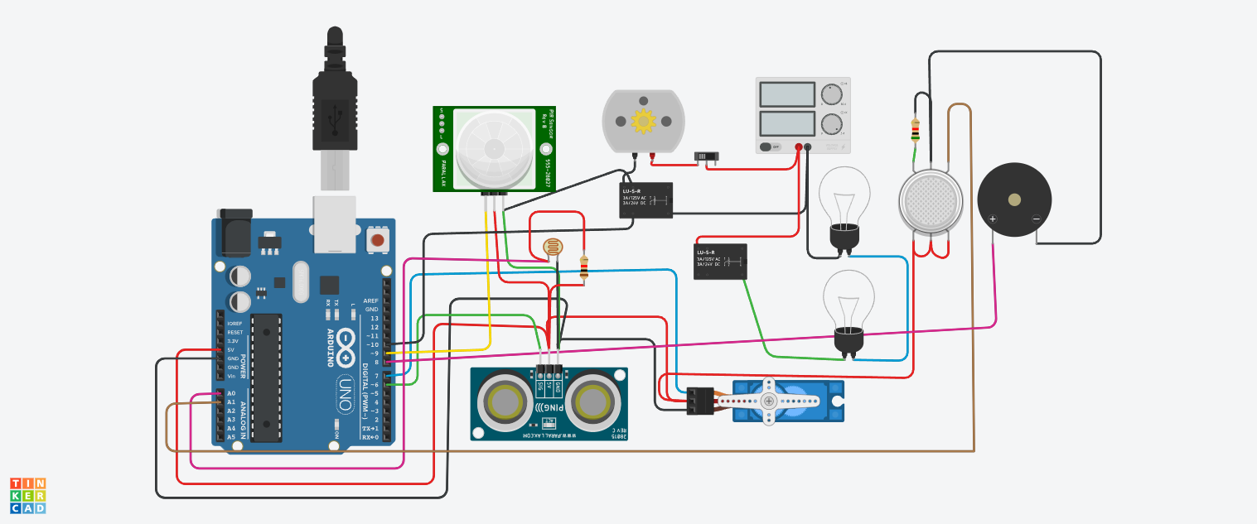

“Home automation” refers to the automatic and electronic control of household features, activity, and appliances. In simple terms, it means you can easily control the utilities and features of your home via the Internet to make life more convenient and secure, and even spend less on household bills.

Home automation is a network of hardware, communication, and electronic interfaces that work to integrate everyday devices with one another via the Internet. Each device has sensors and is connected through WiFi, so you can manage them from your smartphone or tablet whether you’re at home, or miles away. This allows you to turn on the lights, lock the front door, or even turn down the heat, no matter where you are.

The above circuit is done using the arduino board, DC motor, PIR sensor, LED, temperature sensor, relay.

If the temperature increased to a certain level the fan will be on (dc motor), if the brightness of the room is low, the LED will be on

**Program:**

|  |
| --- |
| #include <Servo.h> |
|  |
| int output1Value = 0; |
| int sen1Value = 0; |
| int sen2Value = 0; |
| int const gas_sensor = A1; |
| int const LDR = A0; |
| int limit = 400; |
|  |
| long readUltrasonicDistance(int triggerPin,int echoPin) |
| { |
| pinMode(triggerPin, OUTPUT); // Clear the trigger |
| digitalWrite(triggerPin, LOW); |
| delayMicroseconds(2); |
| // Sets the trigger pin to HIGH state for 10 microseconds |
| digitalWrite(triggerPin, HIGH); |
| delayMicroseconds(10); |
| digitalWrite(triggerPin, LOW); |
| pinMode(echoPin, INPUT); |
| // Reads the echo pin, and returns the sound wave travel time in microseconds |
| return pulseIn(echoPin, HIGH); |
| } |
|  |
| Servo servo_7; |
|  |
| void setup() |
| { |
| Serial.begin(9600); |
| pinMode(A0, INPUT); |
| pinMode(A1,INPUT); |
| pinMode(13, OUTPUT); |
| servo_7.attach(7, 500, 2500); //servo motor |
|  |
| pinMode(8,OUTPUT); |
| pinMode(9, INPUT); |
| pinMode(10, OUTPUT); |
| pinMode(4, OUTPUT); |
| pinMode(3, OUTPUT); |
|  |
| } |
|  |
| void loop() |
| { |
| //------light intensity control------// |
| |  | | --- | |  | | //-------------------------------------------------------------- | |
|  |  |
| int val1 = analogRead(LDR); |
| if (val1 > 500) |
| Serial.print("Bulb ON = ");  Serial.print(val1);  }  else  {  digitalWrite(13, HIGH);  Serial.print("Bulb OFF = ");  Serial.print(val1);  }  //--------------------------------------------------------------  //------ light & fan control --------//  //--------------------------------------------------------------  sen2Value = digitalRead(9);  if (sen2Value == 0)  {  digitalWrite(10, LOW); //npn as switch OFF  digitalWrite(4, HIGH); // Red LED ON,indicating no motion  digitalWrite(3, LOW); //Green LED OFF, since no Motion detected  Serial.print(" || NO Motion Detected " );  }  if (sen2Value == 1) {  digitalWrite(10, HIGH);//npn as switch ON  delay(3000);  digitalWrite(4, LOW); // RED LED OFF  digitalWrite(3, HIGH);//GREEN LED ON , indicating motion detected  Serial.print(" || Motion Detected! " );  }  delay(300);  //---------------------------------------------------------------  // ------- Gas Sensor --------//  //---------------------------------------------------------------  int val = analogRead(gas_sensor); //read sensor value  Serial.print("|| Gas Sensor Value = ");  Serial.print(val); //Printing in serial monitor  //val = map(val, 300, 750, 0, 100);  if (val > limit)  {  tone(8, 650);  }  delay(300);  noTone(8);  //--------------------------------------------------------------  //------- servo motor ---------//  //-------------------------------------------------------------  sen1Value = 0.01723 * readUltrasonicDistance(6, 6);  if (sen1Value < 100)  {  servo_7.write(90);  Serial.print(" || Door Open! ; Distance = ");  Serial.print(sen1Value);  Serial.print("\n");    }  else  {  servo_7.write(0);  Serial.print(" || Door Closed! ; Distance = ");  Serial.print(sen1Value);  Serial.print("\n");  }  delay(10); // Delay a little bit to improve simulation performance  } |

TINKERCAD LINK

<https://www.tinkercad.com/things/kfYCWTrhAL6-smart-home-automation>